Circle Language Spec: Commands

A Call in a Call Show Privates When Running in a Diagram
The rule, that a call in a call only shows private contents when it is running, was already covered conceptually in the article A Call in a Call Shows Privates When Wunning. The current article demonstrates the concept in a diagram.

A call inside another call only contains its private content when it is actually running.

If a call is not running:

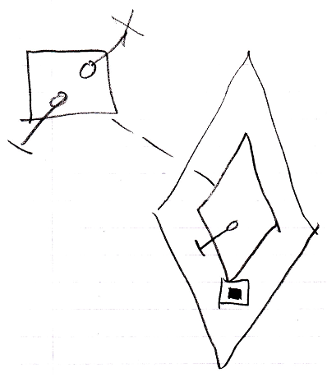

Then you would have to hop to the definition of a call to see the private contents of the command.

When a call is running, you do see its private contents:

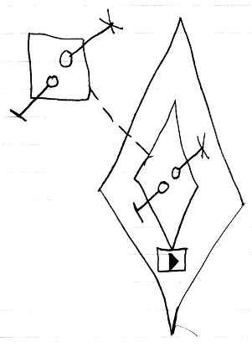

Not creating a call’s private contents before it even runs, takes away discussion about when to display and when not to display a command’s private contents.

